**COMPARACIÓN DE HERRAMIENTAS**

**Rational Software Architect**: Mac OS X, Red Hat Linux, SUSE Linux, Ubuntu, Windows (HTTP or Download Director)

**Rational Software Architect for WebSphere Software**: Red Hat Linux, SUSE Linux, Ubuntu, Windows, Mac OS X (HTTP or Download Director)

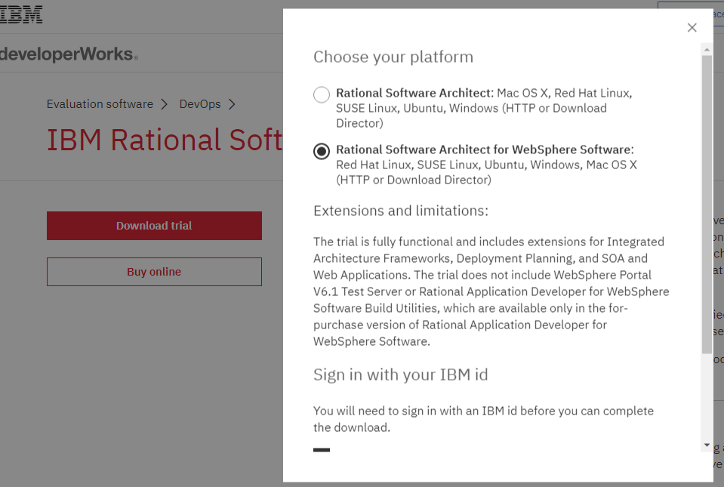

Descarga: <https://www.ibm.com/developerworks/downloads/r/architect/index.html>

Documentación y/o ayuda:

Diferentes herramientas de la familia:

<http://www-03.ibm.com/software/products/es/rational-software-designer-architect-fam>

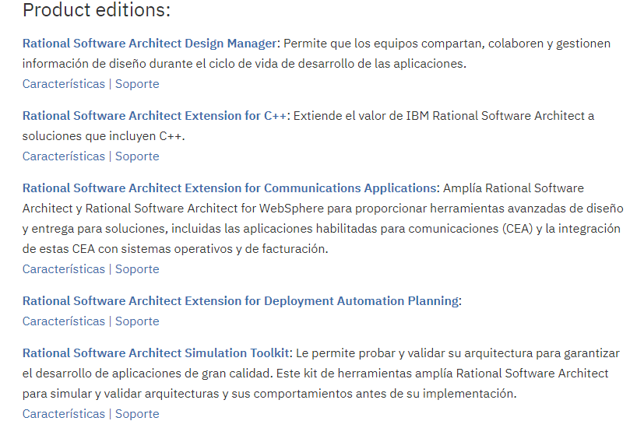

__

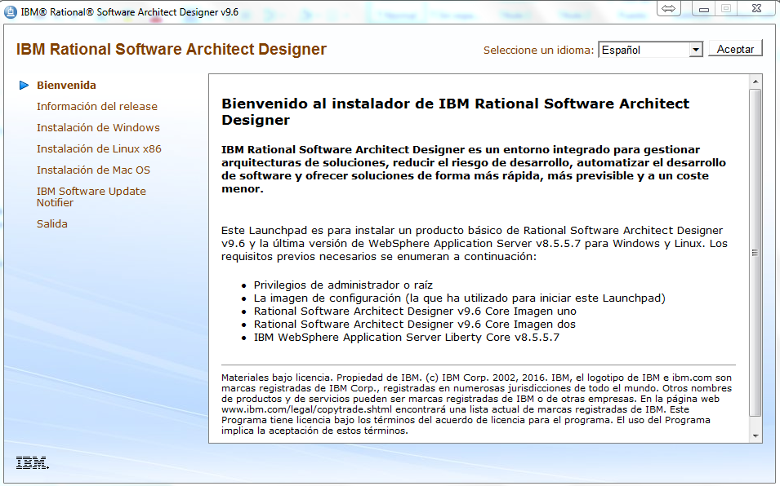

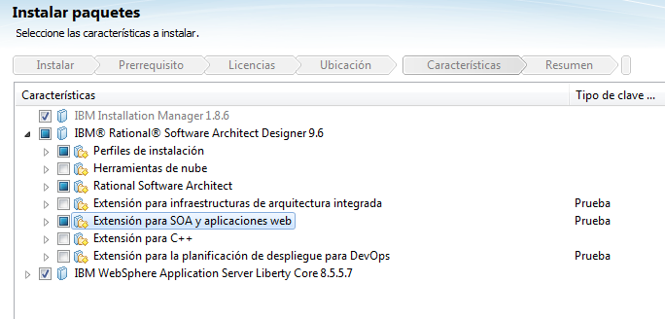

Enterprise

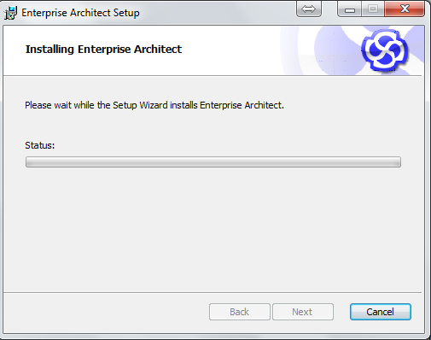

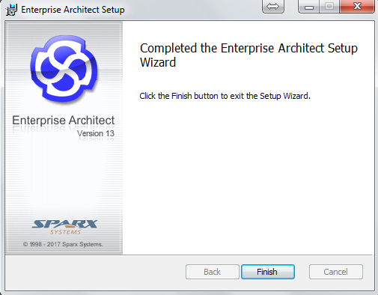

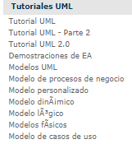

<http://www.sparxsystems.com.ar/products/ea_sysreq.html>

